Studio Practice Assignment 1

## Introduction

This report is an analysis of the game Swords and Potions, which is a third person freemium game. A freemium game is where the game is free to download but some extra content costs money to download (Reeves 2013). The game is set in the medieval age with the Main Character being a young merchant who owns a shop.

The objective of the game is to increase the size and reputation of the shop by making in game profit. To achieve this, the player must build and sell in game items to customers throughout the kingdom.

## Marketing

As the game is browser based an advertisement campaign would be far too expensive to be covered by any profits generated from within the game, instead this game is marketed via several online games companies and websites like Kongregate, Armour Games and Edgebee.

This method is highly reliant on good reviews on the game forums, social media, and word of mouth. This means the game needs to be addictive and challenging, to encourage this and ensure users repeatedly return to the game as well as make in game purchases.

Responding to both positive and negative feedback with updates, patches, further media activity and further marketing the game through community building , evidence of which can be seen from 10th November 2013 update which increased the capacity size of resource bins from 30 units to 120. (Kronoan: 2013).

## Revenue

This game relies on three types of revenues;

1. The game draws players to various websites from which the developer may receive some pay-per-click revenue.
2. There are in game adverts which again may produce more pay-per-click revenue.
3. There are in game in game purchases the player can choose to use for example starter packs (A Fandom User 2012) which is a form of Endowed Progress (Conti 2016).

## In Game Mechanics That Drive Revenue

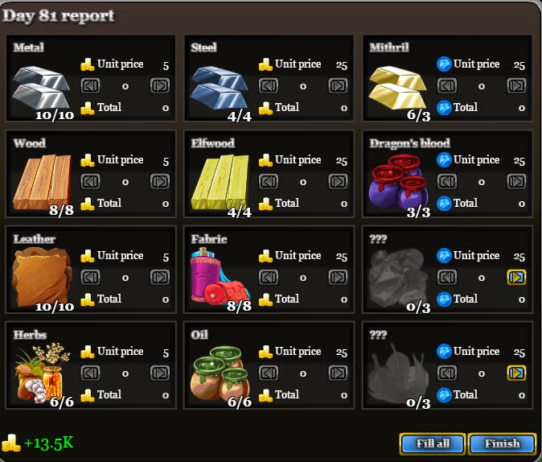

One mechanic in the game that drives revenue is the in-game resources. The player after each in game day ends will come to the screen shown in figure 1. The Resources are split into three groups based on rarity and price. The first column is the Smithing materials and cost five gold pieces. The second column is Woodworking Materials and cost twenty five gold pieces. The last column are the Magical Materials the player has to pay twenty five tokens equalling about $3 per each unit and the pricing for tokens is shown on figure 2. This drives revenue because the resources that require tokens can otherwise only be obtained by completing quests and gaining from real time daily spins (Fandom User 2013), causing other players to envy the ones that have these resources.

Figure 1

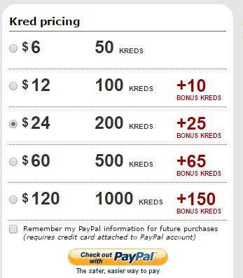

A fellow player of this game Kronoan believes that purchasing these resources after the update are way too expensive and quote “it’s not worth it” and “the tokens can be better spent making recipes”. (Kronoan 2013).

Others disagree, which shows this element of the game is successful in generating media noise and can afford to charge their players a lot more.

Figure 2

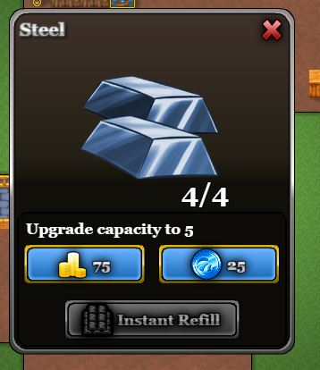

A further mechanic in the game that drives revenue is the in shops resources capacity load / bins. When the player first plays the game each normal resource bin has a capacity of three units, the player can increase the capacity of these bins by either using in game gold pieces or using twenty five tokens which would cost the player $3. This is shown on figure 3. Once a bin reaches a capacity of thirty the cost of further increases goes up from one extra space to five. This mechanic drives revenue because players can spare their gold and use it for something else, this is known as Dual Currency (Jamornh 2012). Kronoan believes that after reaching a certain amount of capacity it becomes too expensive and almost not worth purchasing, suggesting the in-game gold should be used to make potions for sale instead (Kronoan 2013). Therefore this convinces players to use tokens rather than gold.

Figure 3

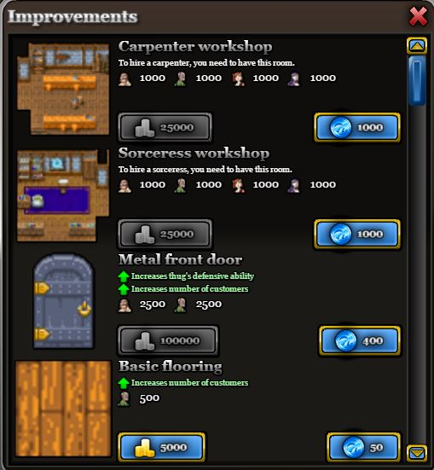

A further mechanic in the game that drives revenue is the in game shop improvements store. The store has all sorts of improvements like and metal front door and wooden floorings which are shown on figure 4, these extras help the player in specific ways like the metal door helps stop robbers robbing your store (A Fandom User 2015). Players can purchase improvements with in game gold pieces or tokens and the player is charged depending on the improvement and its effects towards the game. For example, the metal door costs the player 10,000 gold and must wait several in game hours before they can use the item, or 400 tokens and instantly get the item which another player Kalabin likes (Kalabin 2011) and would cost the player around $45.

Figure 4

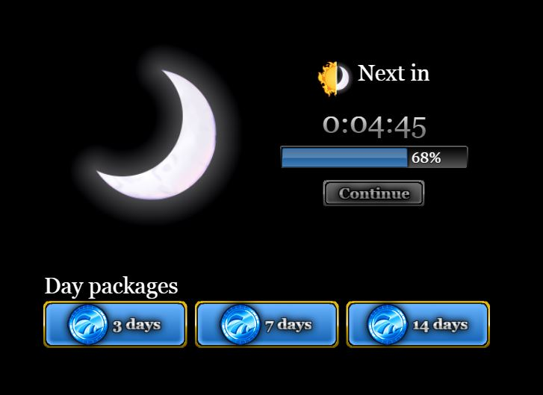A further mechanic in the game that drives revenue is the gate where the players has the choice to pay for day packages to continue progressing through the game or wait a certain amount of time and then can progress through the game. This is called Time Gating (Nelson 2013) as well as Region Gating (Hauteville 2011)

There are three day packages available for the player once they run out of free days. The first one is three days and costs 30 tokens, the second one is 7 days and costs 80 tokens and the last one is 14 days costing 120 tokens. This is all shown on figure 5. This drives revenue because players

Figure 5

# Conclusion

I think the in game resources mechanic are priced well for the initial start of the game, and they clearly state the difference in value and how they differ in rarity. It would be useful if the player could affect these prices via a sale or a two- for-one offer etc,

I do agree with what Kronoan says about the third column of resources being expensive and that there should be an option to pay with in-game gold as well as tokens. Which in turn would increase the developer’s revenues by players purchasing tokens so they don’t have to save up gold for the resources and essentially be psychologically drawn to purchasing more tokens, or otherwise players will have to save up gold which isn’t really a problem for players playing the game for a lot longer than others and in turn earn all the gold required.

I also think that the resource capacity upgrades and day packages are way too expensive for what the player gets in return and they should be a lot more appealing towards the player in an attempt to get more purchases.

However the in game Improvements Store has great appeal towards all players because they give the player the option to either purchase the item with gold or tokens. If the player purchases the item with tokens the build time for that item is discarded which I think is a great incentive to buying these items with token rather than gold and Kalabin thinks this also.

### Total Word Count: 1120

## References

Oxford, N. (2012). *Swords and Potions Review.* Available: <https://goo.gl/10v3o7>. (Last accessed 11th Nov 2016).

Kalabin. (2011). *Cooperation Improvement Mechanics.* Available: <https://goo.gl/PBzXnZ>. (Last accessed 11th Nov 2016).

A Fandom User. (2015). *Special* *Improvements.* Available: <https://goo.gl/walnxN>. (Last accessed 11th Nov 2016).

TaoGaming. (2011). *Swords and Potions & Thoughts of Real Games.* Available: <https://goo.gl/pJcgxD>. (Last accessed 13th Nov 2016).

Kronoan. (2013). *Resources.* Available: <https://goo.gl/XW9YIf>. (Last accessed 13th Nov 2016).

Rankin, K. (2013). *Critical Analysis Template.* Available: <https://goo.gl/38zzCf>. (Last accessed 16th Nov 2016).

Fandom User. (2012). *Starter Packs.* Available: <http://swordsandpotions.wikia.com/wiki/Starter_packs>. (Last accessed 6th Dec 2016).

G, Conti. (2016). *The Endowed Progress Effect.* Available: <https://goo.gl/0ZMeO9>. (Last accessed 6th Dec 2016).

Jamormh. (2012). *Dual Currency vs One Currency.* Available: <https://goo.gl/YDqdB8>. (Last accessed 6th Dec 2016).

Hauteville, C. (2011). *Gating.* Available: <https://goo.gl/cxO1oq>. (Last accessed 6th Dec 2016).

Nelson, B. (2013). *Optimize Time Gating in Spectrum Analysis.* Available: <https://goo.gl/AWhGQW>. Last accessed 6th Dec 2016.

Reeves, D. (2013). *Premium vs Freemium vs Subscription.* Available: <https://goo.gl/FWbuVx>. (Last accessed 6th Dec 2016).